Master Functional Document

Application | NGERP - Centra
Service Bundle | Master Management
Service Request | Sales Rep Info

Description :

The Sales Rep Master is used to show the basic information about the representative and invoices, orders Customer RMA and commercial discount made by a particular sales representative.

Workflow Process :

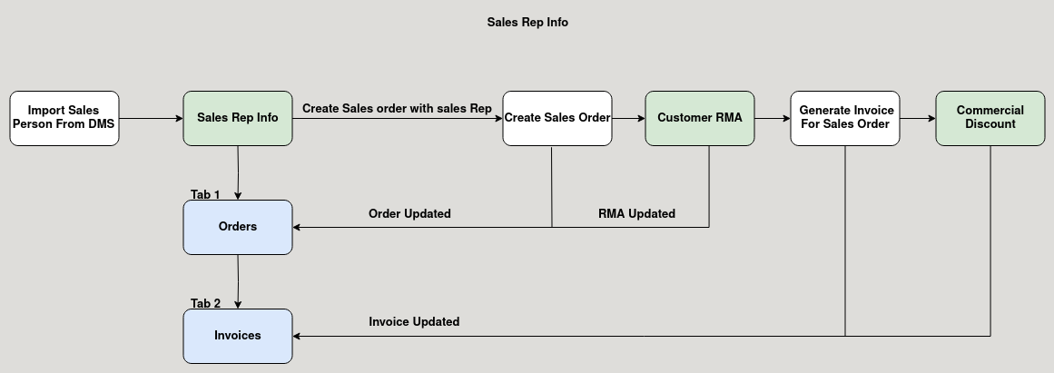

Business Rules :

- The Sales rep master screnn gets its data from the sales person master.
- It show the basic details of the sales representative.
- It shows all the sales order, invoices and Customer RMA made by the sales person.
- It shows the sales order, invoice, Customer RMA and Commercial discount of all document status (Completed, Draft, Inprogress, Invalid)

